Jadavpur Central Road
INSTRUMENTATION STUDY CENTRE

Annual Report 2014-15

Registration No: S / 2L / 4
INSTRUMENTATION STUDY CENTRE
50B, Central Road, Jadavpur
Kolkata– 700 032
Phone no:9831762415
Email: instrumentationstudy@gmail.com

Activities of the centre
Our main interest is to encourage the young boys and girls in the field of electronics and instrumentation. Many needy students can get a scope to learn subjects like electronics. Demonstration of different models will encourage the students to encourage them in this direction. It will strengthen our technical education. Knowing some techniques the students may also get some scope to use it commercially. They can also set up small scale business in this field. Our society will definitely be enriched by our effort. Different write ups on different aspects of electronics and instrumentation including its impact on our society and culture may be useful.
This is a low budget program. Apart from our regular teaching and research we try to do this work. Around 50 students may be trained in our homely environment every year. But we believe that except the training of 50 students, some of our ideas may be useful to develop a general awareness in the field of electronics and instrumentation of our society. In that sense our activity has a broader meaning. We will request all the resourced persons, business persons and organizations to encourage the technical education of our young generation to equip their hands whenever it is possible. Some others may take initiation to set up different technical training centers/institutes at different places.

Activities in this year, 2014-15 -
Celebration of the Year Of Light:
Like previous year we have taken different programs. Since this year is the year of light. We have tried to take up some programmes about it. We have arranged lectures and also prepare notes on LEDs suitable for the children.

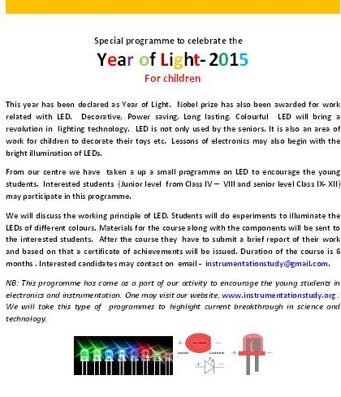

A short notes on LEDs prepared in this year:

Basic Experimental Techniques for developing Technical Skill of the Children
(Through Picture)

Family project to work on together

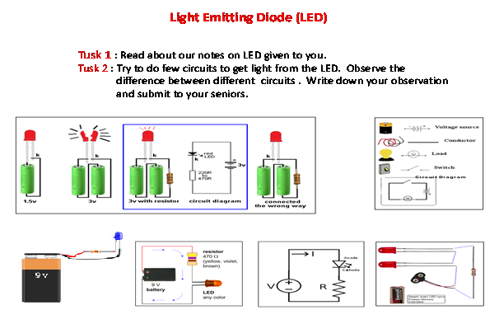
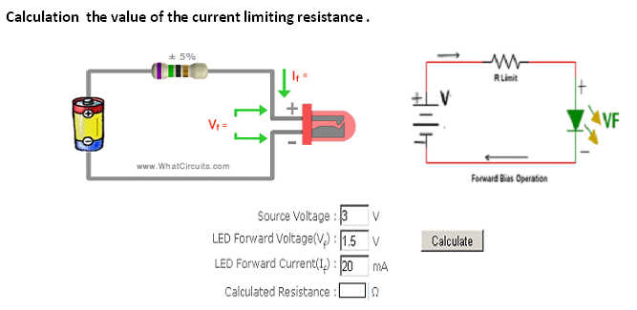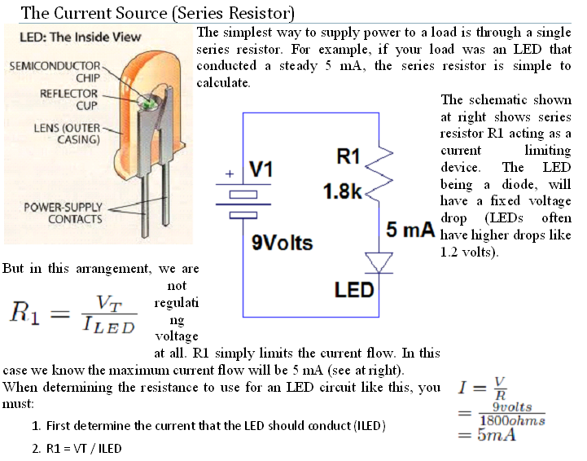

Awards: Z. H. Sholapurwala Best Instrumentation Award was bestowed to the following students jointly.

No | Students Name | Model Project
1. | Md. Raheel Khan | Propagation of light through optical fiber.
2. | Ayan Gupta | Light detection by photodetector.
3. | Rahul Kumar | Water level indicator.

Other Activities:

In this year we have arranged for lectures and demonstration in few schools. Around 100 students at different level participated in our programme.

Apart from this different activities have been taken up. Some of these activities are mentioned here.

- In this year we have celebrated our foundation day on 23rd April at Camellia Institute Of Technology and Management, Bainchi , Hoogly.
- Students are awarded with certificates for their courses.
- Invited lecture was delivered by Dr. Kalobaran Das Principal of Camellia Institute Of Technology and Management and Pulak Das Dey, Deputy Registrar of Camellia Institute of Technology and Management. Also Ashok Kumar Sarkar, HOD of Chemistry , Saikat Singha Roy HOD of ECE, Utpal Kumar Das, Banani Das and Pradip Dalapati faculty of this institute were present there and gave some valuable lecture and shared some experience with the students.
- Certificates were also provided to the participants in the foundation day.
- We have also communicated different organization to take up different programmes in electronics
- We also distributed components for doing experiments on LED s to different students. Around 50 such kits were provided.
- We have also developed different electronic kit suitable for the children.
- We have also delivered different lectures on basic electronics in different schools.

Celebration of foundation day

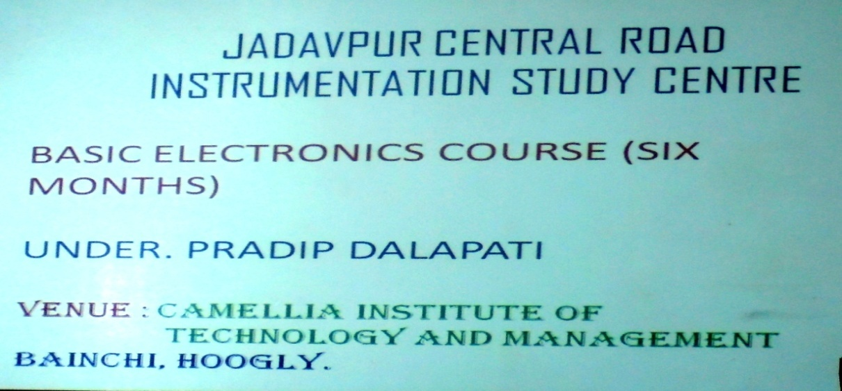

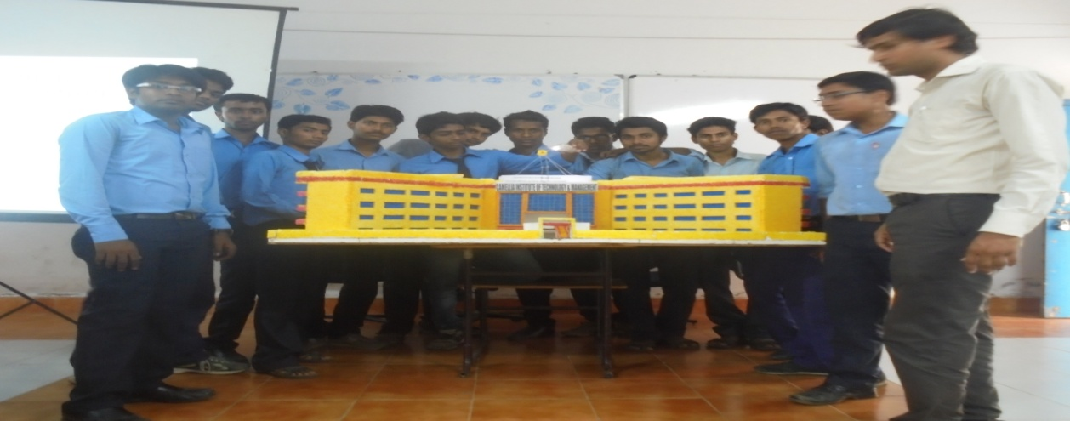

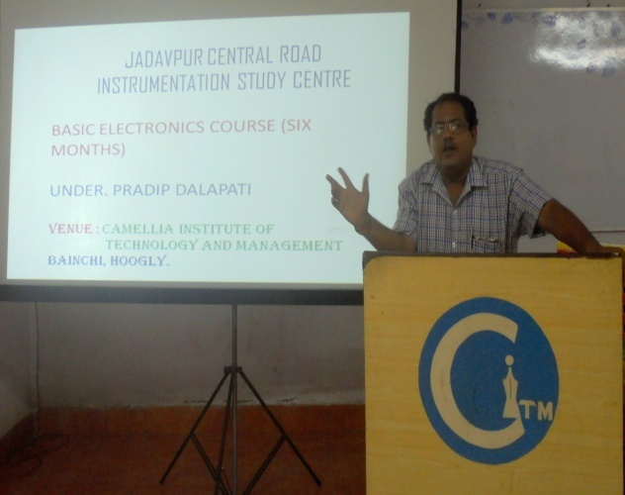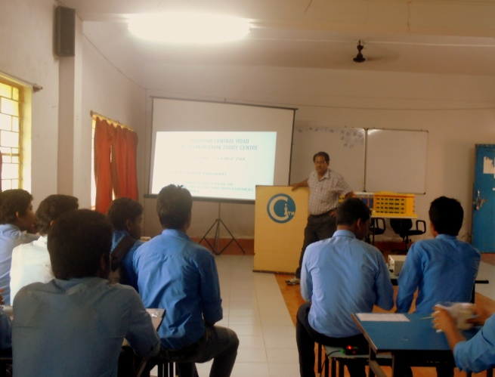
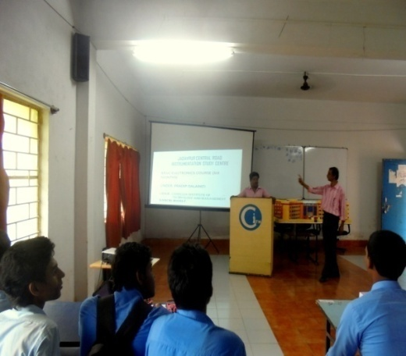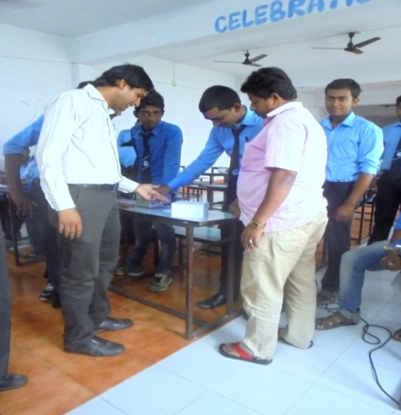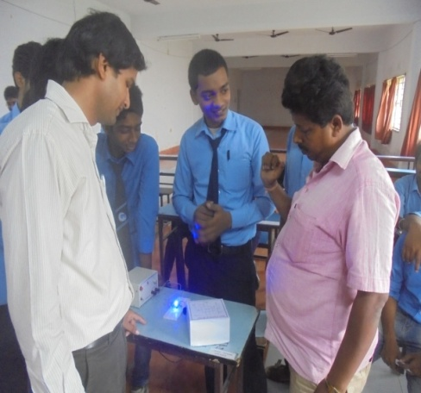

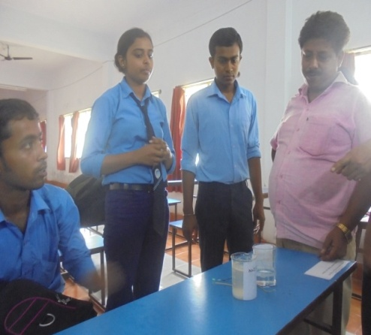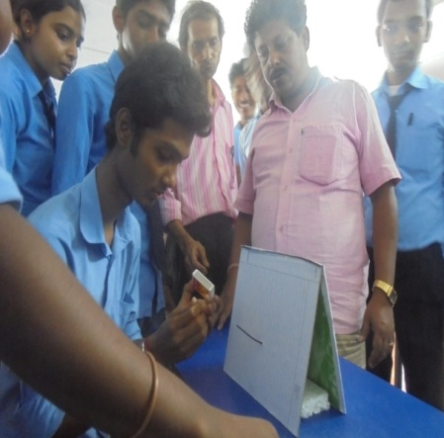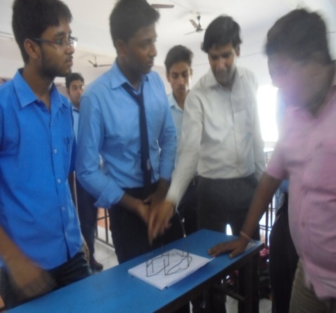

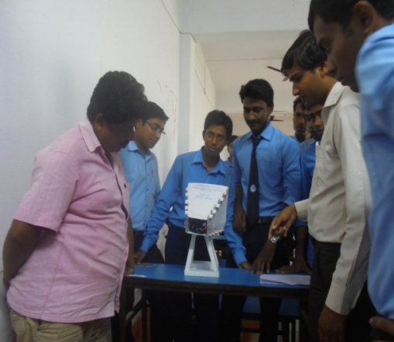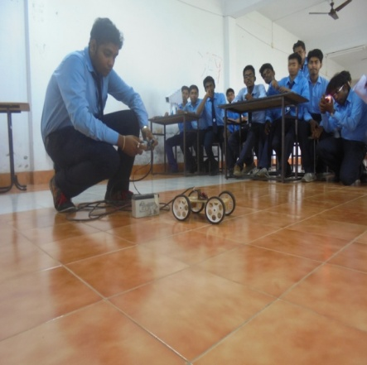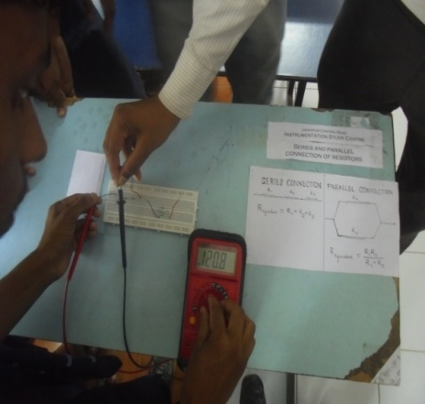

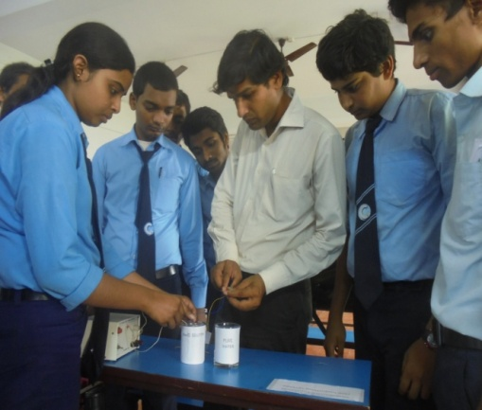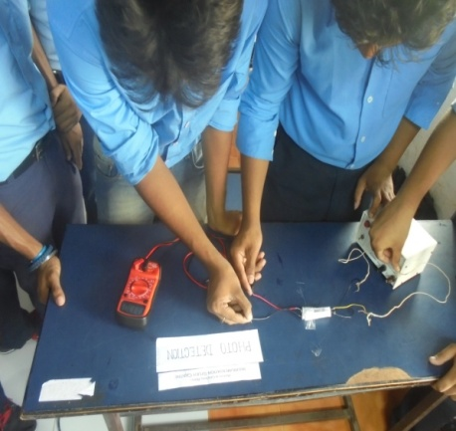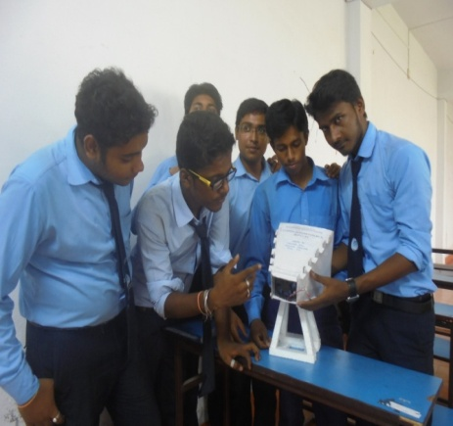

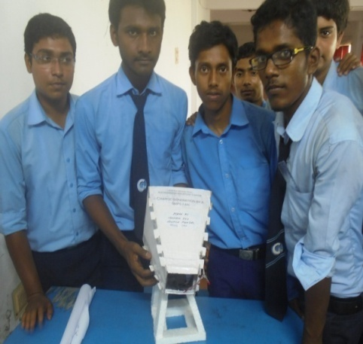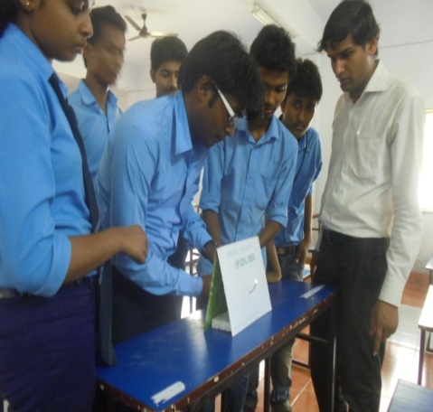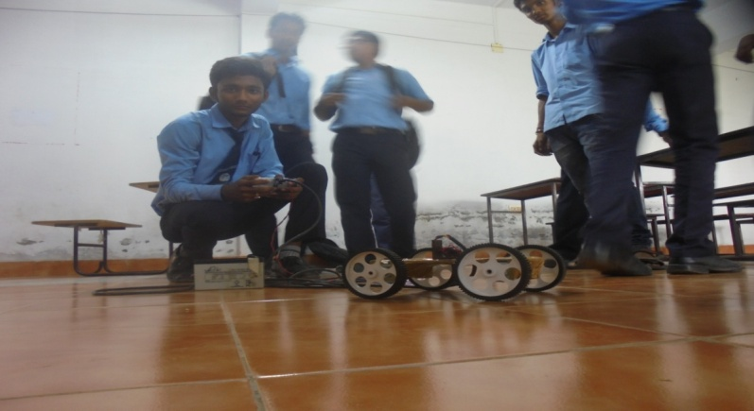

Invited lecture at Jadavpur Vidyapith School

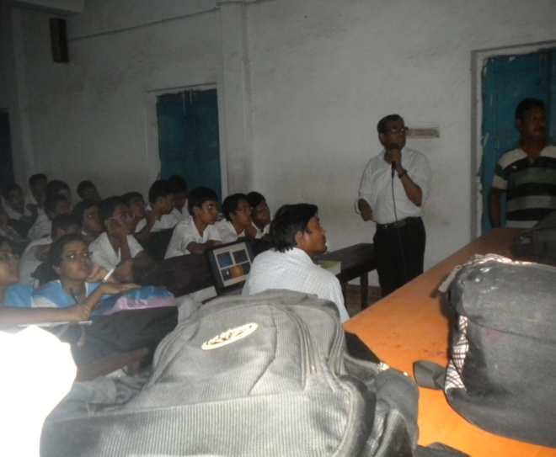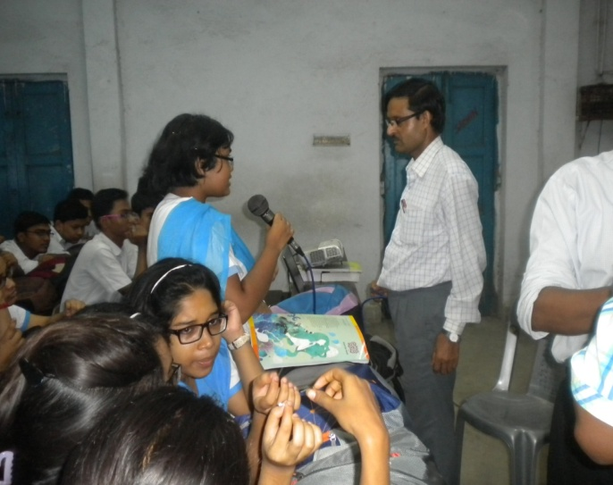

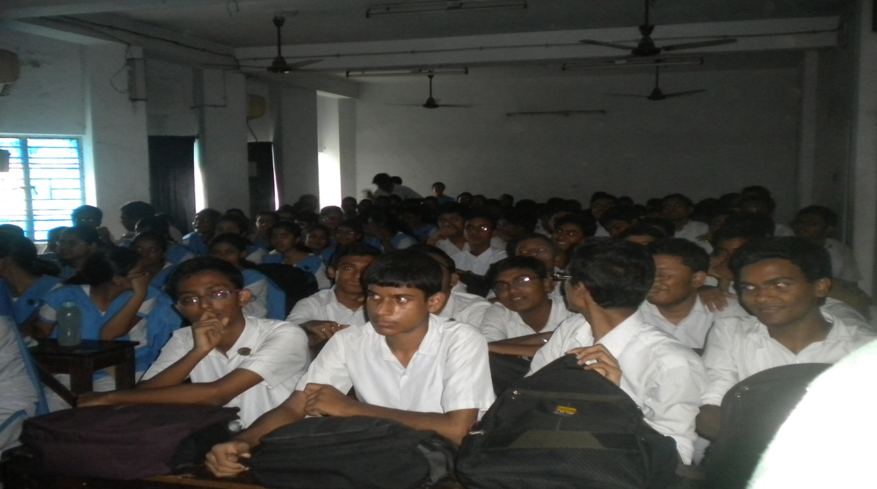

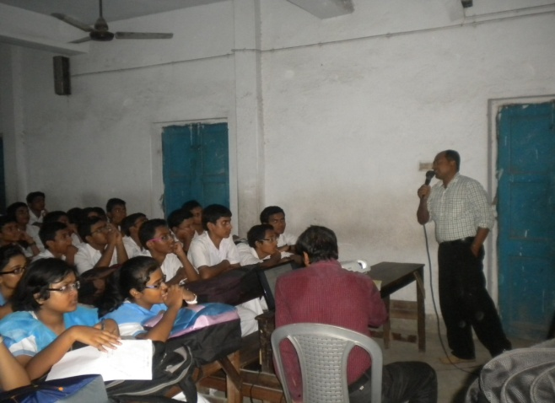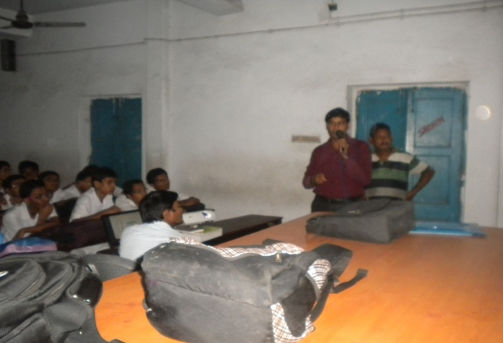

Annual Audit report:
